DISCOUNT SUPPLIER SCHEME

Thank you for joining LALG’s discount supplier scheme.

In return for the discount your business offers LALG’s members, we will provide the following to you:

- A free listing for your business in our newsletter to Members. The listing will usually be included every quarter.

- An entry on LALG’s website with details about your business and a link to your website.

- We may also from time to time mention your business on LALG’s social media.

- A small notice confirming that you are a LALG discount supplier, for you to display on your business premises.

We also hope that you will provide a link from your website to LALG’s.

Members will present their membership card in order to obtain the discount.

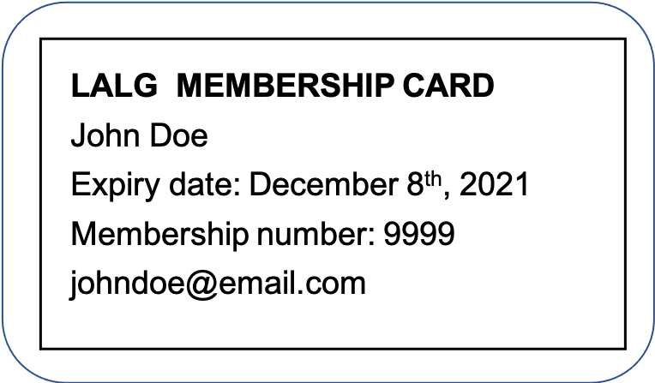

Please complete and sign the form overleaf.

If there are any changes to your details, please email us at:
discounts@lalg.org.uk

Thank you once again on behalf of our Members. We look forward to working with you.

LALG Discount Supplier Scheme

Name of business
Type of business
Address
Telephone
Email
(LALG admin use only)
Website
Details of discount offered
Signed on behalf of business
Name
Date
Signed on behalf of LALG
Name
Date

