These are the summary notes from Philip Sayers the walk leader. More information (a mass and mess) is available, just email Philip via londonvillages@lalg.org.uk
If the notes help you in part, or whole, I wish you well and trust that you enjoy your research, recces’ and walk. Grateful thanks to Wikipedia (well worth supporting) and other sources.
Allow 2 hours a.m. and 2 hours p.m.

LONDON VILLAGES

A memorable maritime meander
Bermondsey Beach to Rotherhithe

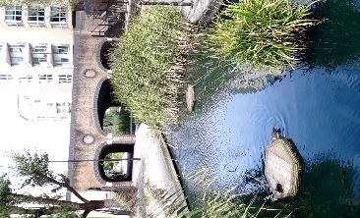
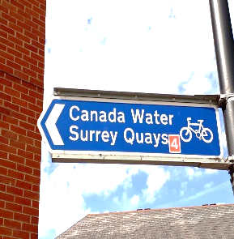
Tuesday 22 June
Wednesday 30 June
Thursday 15 July
Saturday 17 July
Monday 16 August

Leader: Philip Sayers

Trip along the so peaceful south side of the Thames from Tower Bridge to Rotherhithe and beyond. Assess wharfs, warehouses, and wandering wayfarers, via wet locks, dry docks and an amazing view of today’s skyscrapers in the City, and in the Docklands. Judge which are taller, the oddest, the most beautiful? About 4 to 5 miles.

Buy a Travel Card. Weekdays: 9.38 Royston, 9.43 Ashwell, 9.47 Baldock, 9.51 Letchworth GC, 9.55 Hitchin, 10.01 Stevenage. Alight at London Bridge (no changes) 10.44. Meet at the bottom of the escalators between platforms 6 and 7, before the exit barriers at 10.45. About 4 to 5 miles (quite flat, one optional set of steps) with time for coffee and lunch. Home before 6pm. All Overground trains except on the return: two stops on the spacious Jubilee Line, OR bus with a leader; your choice.

Book early to avoid disappointment from 1 June: lalg.org.uk/londonvillages (preferred) or Philip Sayers (NOT Rosemary) via londonvillages@lalg.org.uk £3 contribution to leader’s research expenses on the day. Contact on the day: xxxxx
Group Contact: Rosemary Read lalg.org.uk/londonvillages

Travel card £29.30, less with a rail card. (£5.50 for 2 tube stops Jubilee Line not necy with Travel card).
Buses back to London Bridge: Bus 47 takes 31 minutes (3 mins Jubilee Line) £1.55 by card only Stop B1 at Canada Water, to Hay’s Gallery at London Bridge.
Trains back from London Bridge: 16.16, 16.46, 17.16, 17.46 including Saturday

Email before the day; see who when.
Before the walk email the two maps (1970, 2020) and day details with lunch stop info. Including the menus.

LONDON VILLAGES, A memorable maritime meander, Bermondsey Beach to Rotherhithe

Starting from London Bridge rail station, toilet stop, spacious clean toilets, then back towards the exit barriers TL walk four minutes straight ahead, across the road, into the Hay’s Galleria for coffee and cake. The likely itinerary for the day is then; view over the river, walk along the shoreline examining some key features, lunch at about 1.15 at Canada Water (menus separate) or picnic on the benches, afternoon meander along the Albion canal / water garden, Stave Hill views of the City and Docklands high risers, Russia Dock, Greenland Dock, Canada Water for the journey home. The green dashes show the way.
Coffee in Hays Galleria

Café Rouge 2 + 2 + 1 toilets Costa 1 Cinq, ask for code downstairs (let others know) or back to the good free toilets in the station. Warn late lunch 1.30.

The maritime walk, Philip’s brief outline details, much more available please ask

10.45 exit barrier, toilets, coffee and cake, be at the lookout over the river by 11.30. Lunch 1.30.

Name the buildings opposite on the river north-side
Walk along the river past / under Tower Bridge, stop in Courage yard. First chat; renewal and regeneration of a different kind to what you see have just seen north of the Thames and Canary Wharf (later). Keep a list of all overseas connections e.g. Cardamon, Brunswick. Walk down Butlers Wharf with its lattice work.

TL to the river at the Cardamon Building, Stay on this river promenade
The Clove Building, St Saviours Dock footbridge, link to the Dickens novels (Fagan) Keep to the Thames Path as it is most of the a.m. walk
Toilet stop pub just opposite the King Edward III Manor House. Says no toilets. But ask before + buy a bag of crisps each.
Church of St Mary the Virgin,
TR not Railway Avenue (named after …) , further along; Swan Road
TL at Swan Road; Mayflower statue, quad centenary, turnaround
Walk straight down Swan Road to the Canada Water shops

Lunch at Canada Water
A choice from:
Canada Water Café: menu emailed separately
Decathalon café
Decathalon good toilets: go in the main door past the bouncers then TL immediately down the steps
Leadbelly’s: menu emailed separately
Library café
Mouse and Tail: menu emailed separately
Open air food from mobile vendors
Picnic space outside, sandwiches available from Sainsbury’s
All have limited toilets. Decathalon have more. Go in straight ahead, TL down the steps. Café first floor.

Allow < one-hour for lunch

Turn down Albion Channel, you’ll be amazed. Is this London docklands as was?
at LH turn up to Poolman’s Road TR to junction, TL (Timber Pond Road), TR
Dock Hill Avenue, Stave Hill viewpoint
Go around quarter of Stave Hill TL into the ecology park make your way (TR) into Russia Dock.
Down to Greenland Dock, TR along the dock.
At end of Greenland dock (no way through otherwise) show the huge road bridge, gasp at the scale of the engineering, then TR up the steps TR along Surrey Quays Road, cross over to the left side TL at the mini-roundabout up the left side of Surrey Quays Road. Just after you pass ‘Print Works’ on the opposite side of the road TL into what looks like a service yard ‘’South Point’ (Point?), TL go straight back to Canada Water. TR alongside the Water and cross over the Albion Canal.

Back via Jubilee back to London Bridge then Cambridge train to North Herts. Or bus but go with them. Make sure the bus is gong the right way for London Bridge, very occasionally a bus going the other way (to Catford Dept) uses bus stop B1 (wrongly). Bus proved quite popular.

Travel card £29.30, less with a rail card. (£5.50 for 2 tube stops Jubilee Line not necy with Travel card).
Buses back to London Bridge: Bus 47 takes 31 minutes (3 mins Jubilee Line) £1.55 by card only Stop B1
Trains back from London Bridge: 16.16, 16.46, 17.16, 17.46 including Saturday

A fascinating walk. Plenty more details available just contact Philip above.

Some illustrations on a separate file, see files below

Thames Tideway Tunnel

By Thames Tideway Tunnel - Thames Tideway Tunnel, CC BY-SA 3.0, https://commons.wikimedia.org/w/index.php?curid=24145912

On the North side
Olivers Wharf; more housing, waterside gardens
The pleasant pub next door = ‘The Town of Ramsgate’ where James II’s hanging judge captured
St John’s churchyard, Wapping, behind
Wapping High Street
The River Police Museum (Keith’s walk)

Back to the South side
Bermondsey Beach point out
We saw family picnickers there
"The children loved playing with stones and throwing them into the river"
"A place close to home that makes the river real."
"Many people have a swim there, i did too.. and didnt die!"

Dr Salter’s Daydream, a sad tale, lost their daughter; lived in Bermondsey

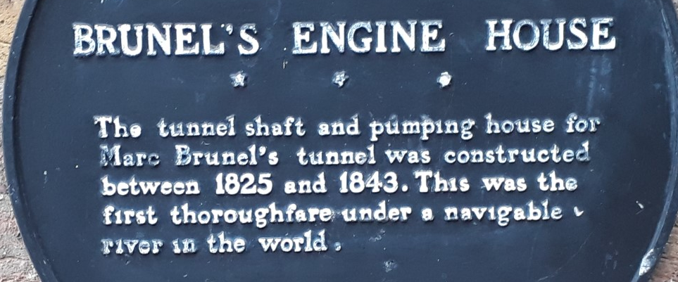

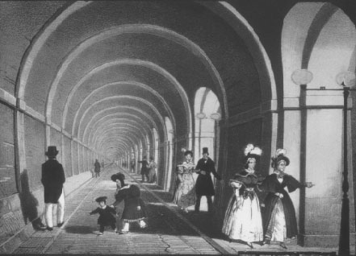

SE16: MASSIVE £3.3BN CANADA WATER MASTERPLAN DEVELOPMENT UNANIMOUSLY APPROVED BY COUNCILLORS

The scheme, the largest in Southwark history, will see the overhaul of swathes of Rotherhithe and Surrey Quays in the next fifteen years. (Southwark News 18 October 2018)

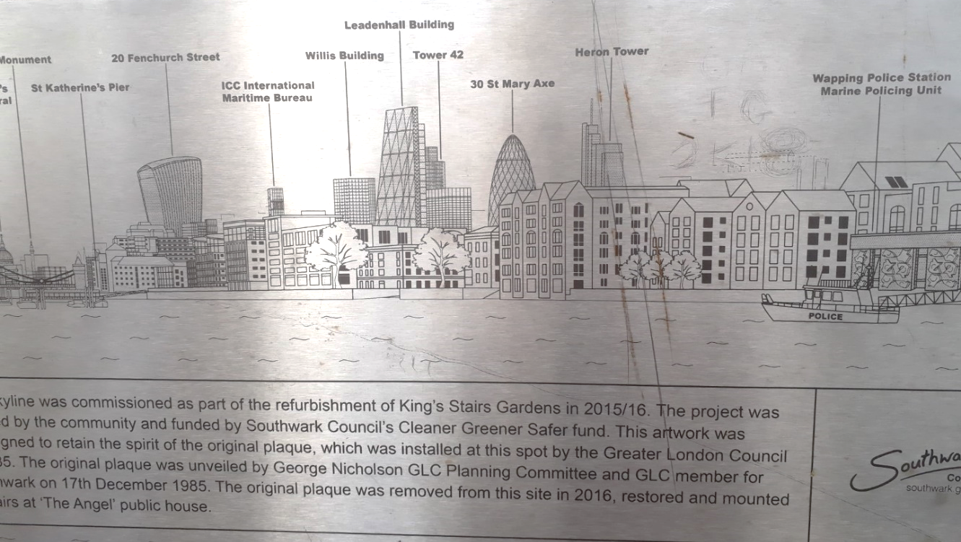

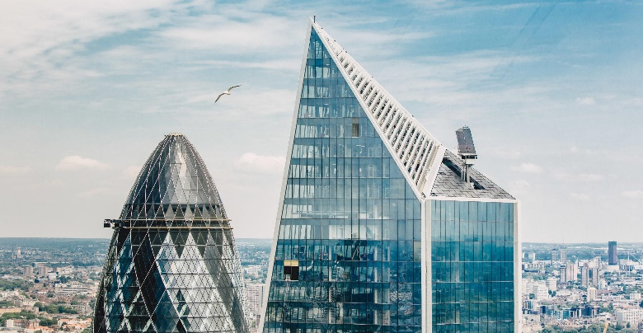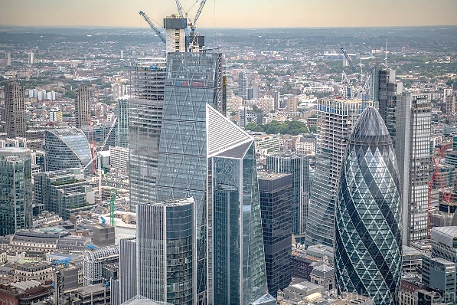

The top of the Scalpel building in London

