These are the summary notes from Philip Sayers the walk leader. More information (a mass and mess) is available, just email Philip via londonvillages@lalg.org.uk If the notes help you in part, or whole, I wish you well and trust that you enjoy your research, recces’ and walk. Grateful thanks to Wikipedia (well worth supporting) and other sources.
The East End, now and then
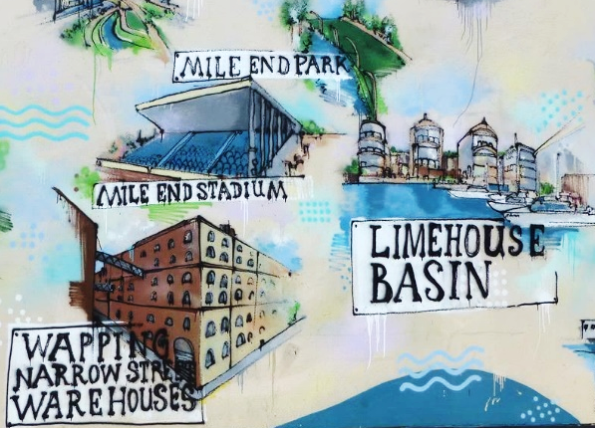
LONDON VILLAGES

The East End
Leader: Philip Sayers

Thursday 20 September
Friday 21 September
Saturday 22 September
Tuesday 25 September
Thursday 27 September

Limehouse, Mile End, Stepney
Water, weavers, wayfarers, and the way into the UK for centuries of refugees and entrepreneurs.
Our walk includes coffee and cake, docks and locks, possibly a mosque, definitely a park on stilts, university refectory lunch and an historic conservation area. Back home in time for tea before 5.30pm. About 4 miles.
To check if any spaces left: contact Philip Sayers (NOT Rosemary) via londonvillages@lalg.org.uk Please provide your LALG membership number and a mobile if possible.
Meet at Letchworth station at 9.15 for the 9.30 train (9.18 Royston, 9.27 Baldock, 9.34 Hitchin, 9.39 Stevenage). Buy an off-peak Travelcard; perhaps team up for a group discount. Rendezvous at Kings Cross at 10.25 by Platform 10 exit barrier. Saturday similar, details later. We ask for £3 per head towards research expenses. Contact on the day: xxxxx.
Group Contact: Rosemary Read
The walk
2 miles + a bit before lunch, 1½ + a bit after lunch. Coffee limited toilets, so stagger.

- Go Limehouse via KGX, Northern line to Bank then DLR to Limehouse. An easy, short interchange at Bank. Take the first DLR train, they all go to Limehouse.
- Husk Coffee and Creative Space, not Mondays. What was the building before ? a project of London City Mission, Previously a Danish church then a Chinese take-away. Warn late lunch at 1.15 +/-
tiffany.scott@lcm.org.uk 5 August 2016
Warn about numbers matt.brinkley@lcm.org.uk June 2018 020 7702 8802 info@huskcoffee.com

A round of applause to the person collecting the most street names associated with international or watery connections e.g. the Danish church, Salmon Lane ….

- Walk over the road, down Branch Street, first left immediately, along the top of the dock parallel to the rail line. Explain about Regent’s Canal and Dock. And the Limehouse cut.
- Turn left down Island Row over Limehouse Cut Explain through the Ropemakers Field park, turn left and walk out to the street not the towpath.
- Oak Lane, Newell Street, St Anne’s Church Explain. TL inside the grounds to main road.
- Cross the road, see the Sailors’ Mission. Explain. Up Salmon Lane. Up to the lock. Half way over the bridge look back at the Lock keepers cottage. Back track, TL at end of bridge with canal on LH side. Walk along towpath north.
- Just before the second bridge over the canal, bear right towards the green finger post, across the road, through the historic park gates. Mile End Park. Explain.
- Point out the Ragged School. Explain.
- Walk up Mile End Park over the A 13, (the park on stilts) then TR off the bridge and park down the steps to the noisy A13, check property prices, TR under the bridge on the main road to Queens Uni.
- LUNCH Uni refectory or continue half a mile down the road to Weatherspoons (an old Methodist chapel) just before Stepney Green tube station.
- Walk through the Uni (Sephardi cemy v. Ashkenazi earlier, come out at People’s Palace. Explain.
Cross road to Harford St, first RH along Ernest St. Eastbury St. Show Louisa Gardens Explain. Up to main road. TL. Along, down Hayfield Pass. Explain. 37 Stepney Green built 1694. More from Pevsner
- St. Dunstans Church (open Thurs by special request) . Malplaqet House, Mercers’ almhouses Explain,

Back to Kings Cross from Limehouse

