These are the summary notes from Philip Sayers the walk leader. More information (a mass and mess) is available, just email Philip via londonvillages@lalg.org.uk
If the notes help you in part, or whole, I wish you well and trust that you enjoy your research, recces’ and walk. Grateful thanks to Wikipedia (well worth supporting) and other sources. Pictures are in the next file down.

The City, from 0 to 2000
LALG ‘London Village’ walk 2017
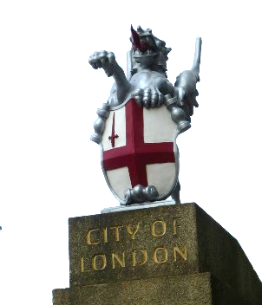

Summary
Piece together the City of London from nothing, through the Romans, back to nothing, through the medieval period to the ultra-modern metropolis that it is today. Highlights include Roman echo’s persisting to this day, the wooden London Bridge, medieval churches, and the very centre of global commerce since 1660. About 4 miles with time for coffee + lunch. All within the square mile of the City.

The Route with a few highlights
Full notes from Philip Sayers

Northern Line to Bank walk underground to Monument for coffee (Fish Street exit)
Coffee Two lovely coffee shops + EAT and Starbucks up the hill on Eastcheap. Warn late lunch 1.30.

Monument commemorates the 1666 great fire of London with a 61ft tall Doric column topped with a gilded urn of fire. It was designed by Christopher Wren and Robert Hooke.

The old London Bridge
From the Monument walk straight down Fish Street to the model of the middle ages London Bridge in the church of St. Magnus the Martyr built in the 1100s (Magnus of Orkney executed after a power struggle). St. Magnus the Martyr stood on the north end of London Bridge for about 700 years from its Roman origins through a series of early wooden bridges to Peter Colechurch’s stone bridge of 1176 – 1209. Until 1750, this was London’s only bridge with sections periodically collapsing for want of maintenance.

Year 0, nothing
Out of the church, walk to the river. History starts here. No bridge, no city, no town, few dwellings, the river much wider with salty marshes on the southern side.

In 54 BC Julius Caesar may have said “I came, I saw, I conquered” but he did not stay.
London itself is a relatively modern construction. Roman in fact. Nothing before that. It is generally accepted that London did not exist before the AD43 second invasion. The Romans had the need and technical capability to bridge the river Thames at the top reach of the tidal flow. In AD 43 Emperor Claudius with 40,000 troops saw to it. Today the tide flows to Teddington, 20 miles further upriver, due to south east England having tilted downwards and the water level rising.

A pocket park
Walk between Old Billingsgate and Customs House, across Lower Thames Street (river up to here) up St Dunstan’s Hill to visit the remains of St Dunstan in the East. London: continuing upheaval of epidemics, pestilence, death, decay, reconstruction, fire, bombing, more reconstruction. A target of natural and manmade disasters.

Roman London, a model of the Roman city with real Roman mosaic. The wall
Continue Great Tower Street, cross Byward Street to All Hallows by the Tower (bits remaining from the 1100s). Find the model of the Roman city in the crypt and fragments of Anglo Saxon crosses in the crypt at All Hallows by the Tower Monday to Friday 8 to 5. and if time at the end the crypt of All Hallows as well (Roman mosaic or floor, Saxon brickwork and William Penn's baptism records + a fascinating museum.) Allow 15 mins. Toilets.

When finished, cross the road. Cut round north of Trinity Square and up into Coopers Row.
Find Grange city hotel, 8 Coopers’ Row. Walk through the open entrance to find on the other side a substantial section of the wall standing 10.6 m high. The Roman part can be seen up to the level of where guards used to walk (4m high), the sentry walk. The upper part was rebuilt in the Middle Ages (Archers loopholes). In the lower part you can see the careful Roman construction of squared stone blocks and a regular double rows of red Roman tiles. The wall went through the centre of what is now The Tower, to the river.

The main gates in the wall were Aldgate (Old Gate) leading to Colchester (therefore important). Bishopsgate leading to Lincoln, York (Ermine Street). Moorgate was actually a postern (a minor door) until made into a gate in 1300s. Name some more …

Mediaeval
Alfred's taking of London and the rebuilding of the old Roman city was a turning point in history, not only as the permanent establishment of the City of London, but also as part of a unifying moment in early England, with Wessex becoming the dominant English kingdom and the repelling (to some degree) of the Viking occupation and raids. While London, and indeed England, were afterwards subjected to further periods of Viking and Danish raids and occupation, the establishment of the City of London and the Kingdom of England.

At the junction of Leadenhall Street and Fenchurch Street stands the Aldgate pump (11) a rare reminder of how Londoners fetched their water before mains supply. Dates back to 1870 and was connected to a nearby well. Condemned in 1876 due to the standard of water not helped by the fact that the supply was filtered through the local graveyard.

The Bevis Mark synagogue is the oldest synagogue in the country and the only one in Europe that has hosted continuous services for over 300 years. Built in 1701 similar in style to Christian churches due to the Quaker architects. Bevis Marks a corruption of Buries Marks has in the mediaeval period Street marked the perimeter of where burials could take place upon lands owned by the Abbots of Bury St. Edmunds.

2000+
Identify the current modern buildings. All built on the original medieval street layout, pre 1666, as no money to buy private property and put in streets, plazas.
- Lloyds’ of London designed Lord Richard Rogers and opened in 1986.
- Cheese-grater; 122 Leadenhall St. 225 metres, 735 ft, Richard Rogers, Stirk, Harbour +
- The Gherkin (Swiss Re) 30 St. Mary’s Axe, Norman Foster + Arup, open 2004, 600ft tall, after 1992 IRA bombing of the Baltic Exchange now in pieces in Tallin, Estonia to be a central feature of the city centre. …..

Leadenhall Market. Owned by the City Corporation. Notice the hooks at first floor level for hanging game. Thriving night-time economy. Go ahead and turn right at the centre walking towards the south, second(?) on the RH side see the doorway where Harry Potter entered the witchcraft world. The door now sold to a collector.
Leadenhall market was originally founded in 1445 is a market for wool, leather meat and fish. The markets walls help stop the spread of the great fire as it was stone built. Closed on Sats, Suns It stands on what was the centre of Roman London.

Lunch here or the good Wetherspoons (open Saturdays), cross over Gracechurch St.

Medieaval alleyways
Exit the market on the west side. Immediately opposite (across Grace Church Street) walk up the narrow St Peters Alley. The church of St Peter upon Cornhill founded on the highest hill in the city and site of the Roman basilica forum (major administrative centre) which survived until the end of the third century A.D. Dickens often mentions Cornhill in his books. In a Christmas Carol Scrooge’s office is based here near an ancient tower of the church whose gruff old bell was always peeping slightly down at Scrooge out of a Gothic window in the wall

See the old mediaeval alleyways at their best. Note the ‘original’ railings back around the churchyard to give a sense of identity to the open space and alleyway. The original railings went the salvage in the Second World War. Church of St. Peter on Cornhill.

TR into Simpsons alleyway, very Harry Potter like. Closed at night time.

The Bank junction is grossly overpopulated with traffic. It has been a high priority project for five years to do something about it. Consultations took five years with Transport for London and taxi drivers arguing against change. Just now being introduced with buses and cycles only on weekdays until evening. The whole thrust is to reduce the habit of driving. But many top bosses within the city have the clout and the contacts to frustrate change. This is the centre of London with the A2, A1 and A6 all starting from here. Horse drawn speeds are still the reality today due to traffic.

The start of commercial London
All the buildings around the Bank underground station are in a Roman style even though erected in the 19th and 20th centuries. The Royal exchange built in 1841, the Mansion house 1739-52. Both have frontages based on Roman temples similar to the Pantheon in Rome. The Bank of England was largely built during 1823 to 37.

The city is the centre of innovation. Insurance started here (after the great fire), stockbrokers started here, all mingling together and fertilising methods of how we work. Now many SMEs.

Bank of England, Mansion House and Magistrates Court just behind, Royal Exchange,

Walk up Prince’s Street, TL onto Lothbury, to the Guildhall and that courtyard we found with the army relaxing. This is the site of a Roman amphitheatre discovered in 1988. Most of the remains of old London are 23 feet below ground level. 2000 years of building, fire and bomb have hidden much of the Roman settlement.

Guildhall
Built between 1411 and 1430, Guildhall is home to the city of London Corporation and has been the centre of city government since the Middle Ages. Being stone built it stopped the flames of the fire and most of the building survived. Guildhall is now the only secular stone building dating from before 1666 still standing in the city.

The east entrance to the Amphitheatre is conserved below the Art Gallery and the arena is outlined in the Yard’s pavement in a circle of paving stones.

Smithfield Market
A Grade II listed-covered market building, was designed by Victorian architect Sir Horace Jones in the second half of the 19th century, and is the dominant architectural feature of the area.

Farringdon Station
The station was opened on 10 January 1863 as the terminus of the original Metropolitan Railway, the world's first underground metro line. 4 mi (6 km). in conjunction with a freight route to take livestock to a depot to its south to supply Smithfield Market; there are cattle ramps onto the street West Smithfield for this purpose. Smithfield was redesignated as a wholesale 'deadmeat' market only before the initiation of services; the freight station last used in the 1920s but remains in situ.

The station frontage carrying the original name Farringdon & High Holborn. The lines from Farringdon to King's Cross run alongside the now culverted River Fleet, which was above ground here until 1734.^{[8]} The station building is an unusually well-preserved piece of early 20th-century London Underground architecture.

Crossrail is a new east-west railway scheduled to open in 2018, and the Thameslink Programme is a major upgrade to the existing north-south Thameslink route, enabling longer and more frequent trains, also scheduled to be completed in 2018.
After the completion of Crossrail, Farringdon will be one of the country's busiest stations with approximately 200tph which equals to a departure from the station every 20 seconds.^{[10]} It will be the only station where passengers can change between Crossrail and Thameslink. Farringdon station is notable because Thameslink trains switch between the 25 kV AC overhead supply used to the north of London and the 750 V DC third rail supply used to the south whilst standing at the platform. This project was installed by the Network SouthEast sector of British Rail in May 1988.

Back to Kings Cross from Farringdon

The Roman London wall
www.romanobritain.org
The current City of London is slightly larger

The City: 0 to 2000 AD, London Villages walk 2017

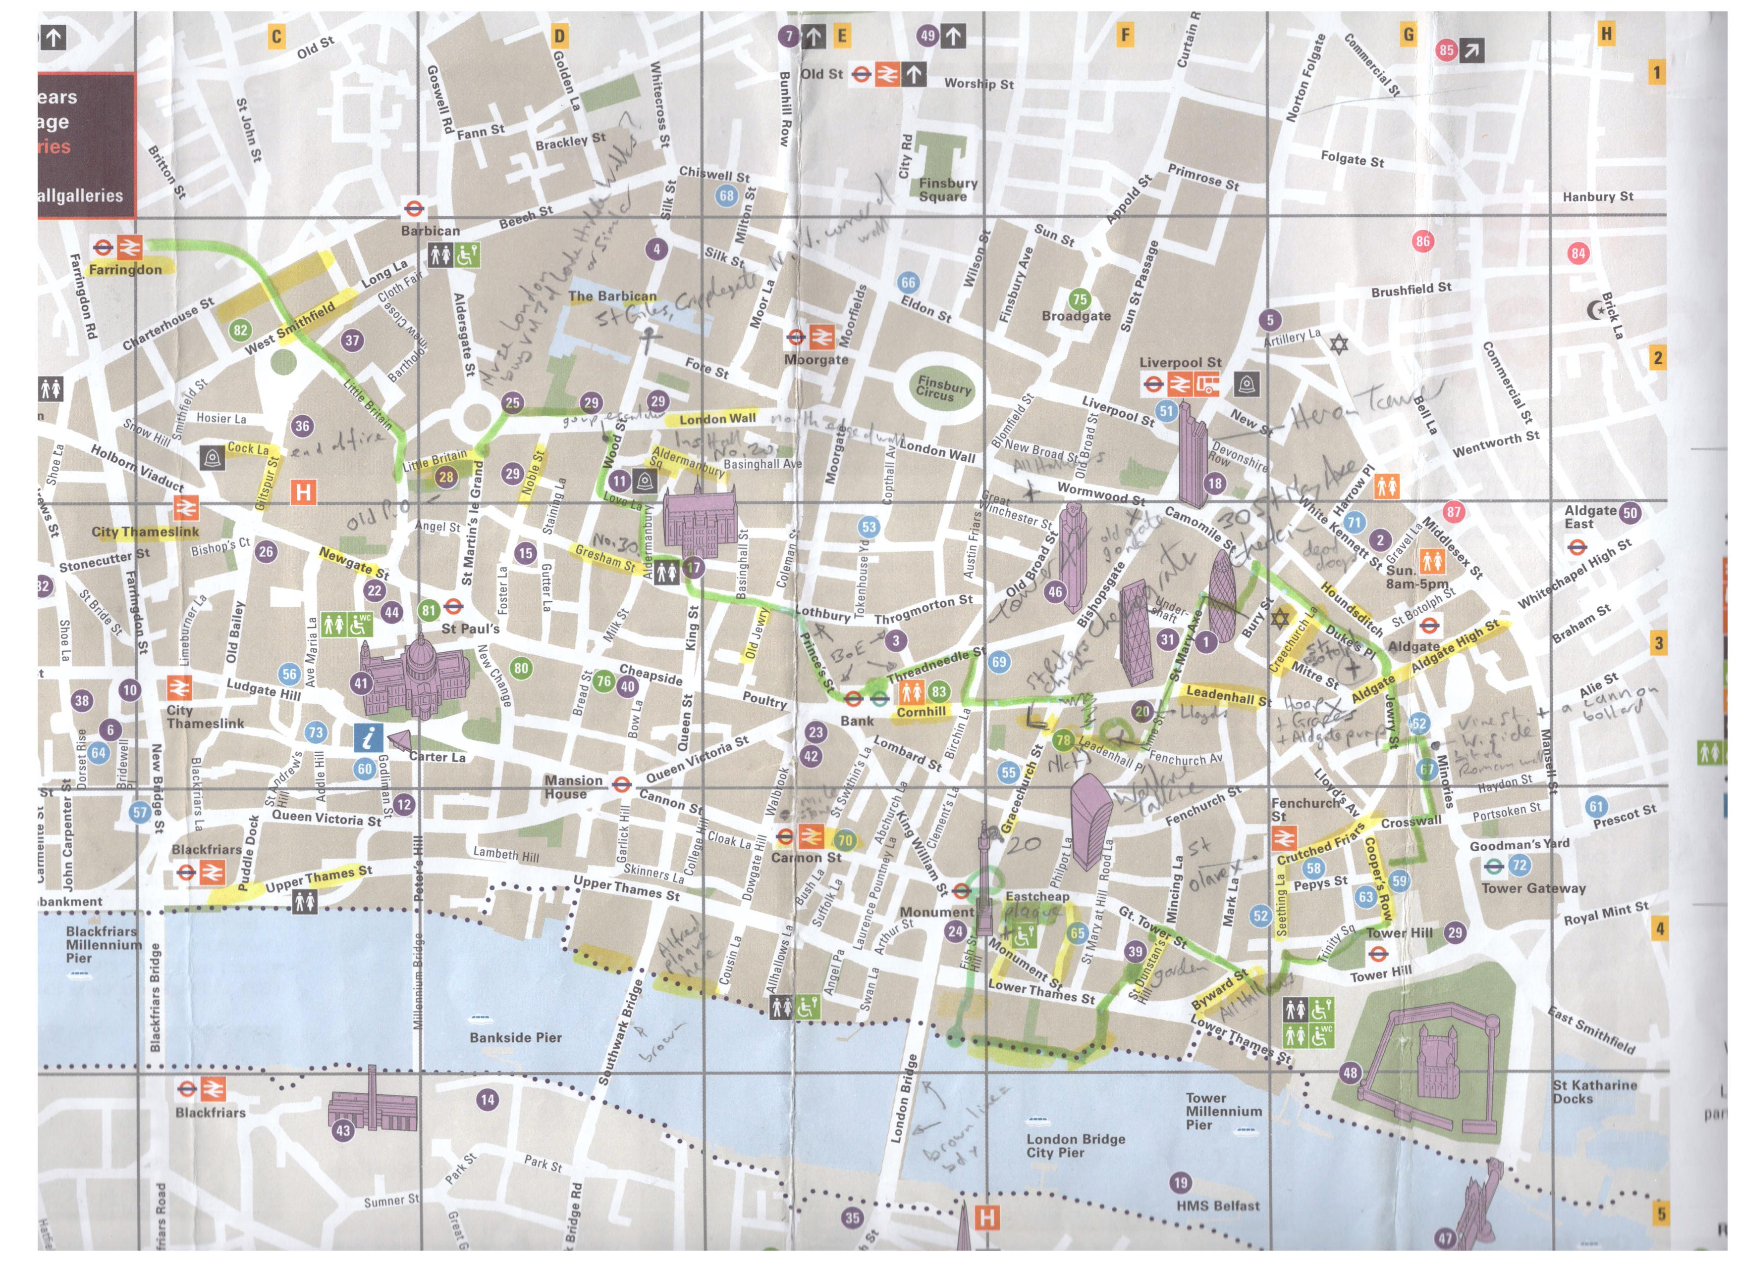
Notes from many sources including the London Museum and Wikipedia with grateful thanks.

The Roman Bridge. Note the islands that were Southwark, the Forum Basilica (right centre), the circular amphitheatre
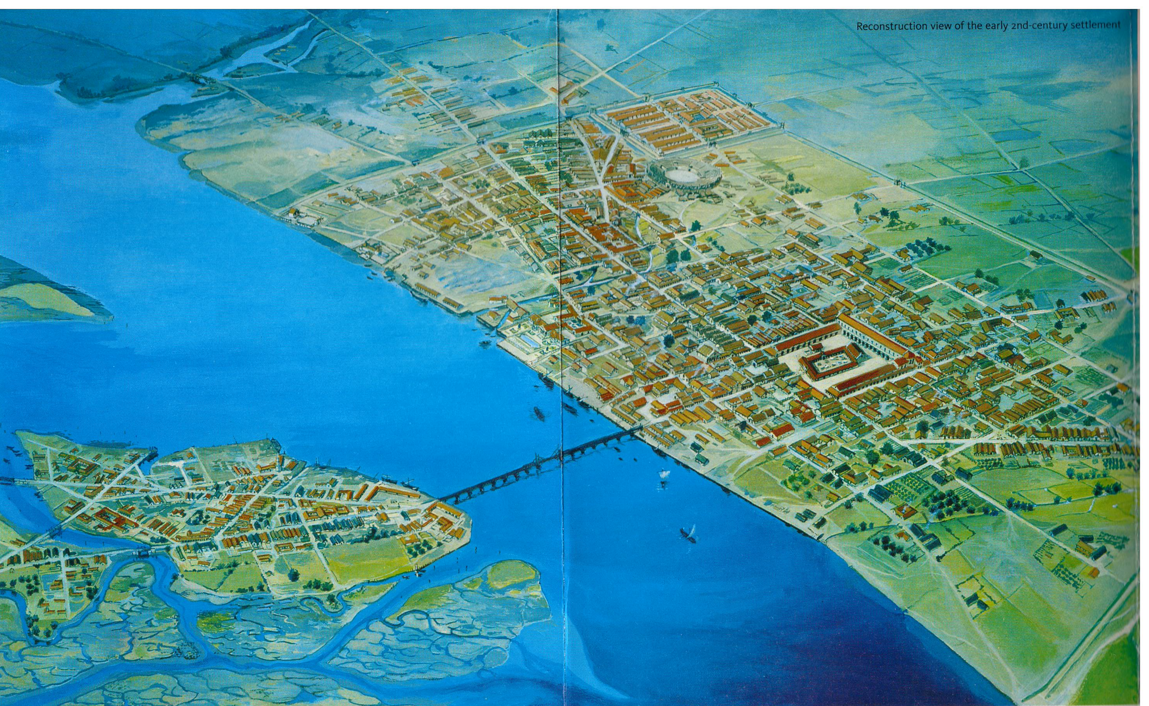

The Roman Bridge. Note the islands that were Southwark, the Forum Basilica (right centre), the circular amphitheatre

