These are the summary notes from Philip Sayers the walk leader. More information (a mass and mess) is available, just email Philip via londonvillages@lalg.org.uk
If the notes help you in part, or whole, I wish you well and trust that you enjoy your research, recces’ and walk. Grateful thanks to Wikipedia (well worth supporting) and other sources.

Pictures only are here. Text in the file above.

The City, from 0 to 2000
LALG ‘London Village’ walk 2017

Summary
Piece together the City of London from nothing, through the Romans, back to nothing, through the medieval period to the ultra-modern metropolis that it is today. Highlights include Roman echo’s persisting to this day, the wooden London Bridge, medieval churches, and the very centre of global commerce since 1660. About 4 miles with time for coffee + lunch. All within the square mile of the City.

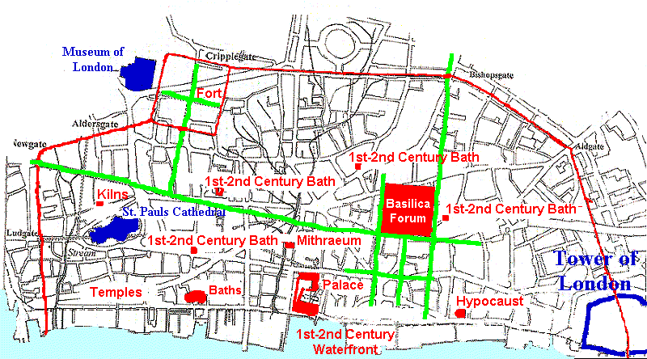

The City: 0 to 2000 AD, London Villages walk 2017

City of London walk

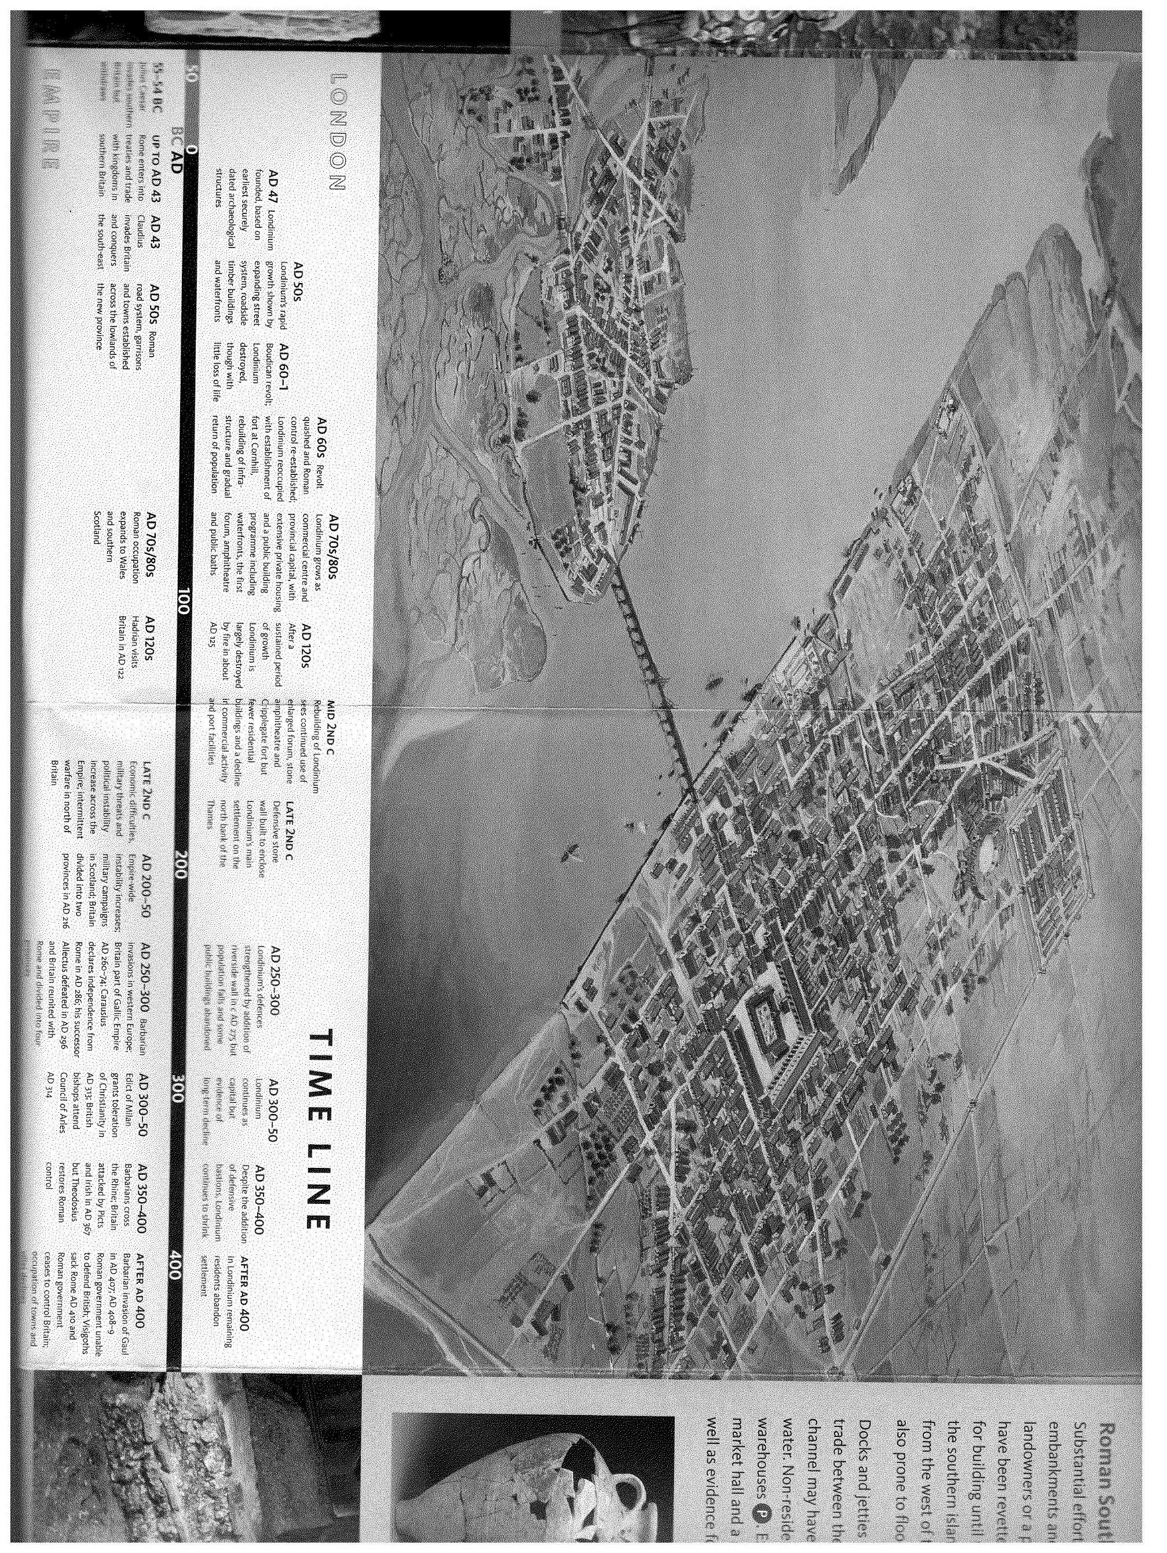

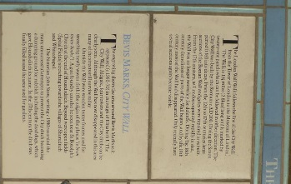

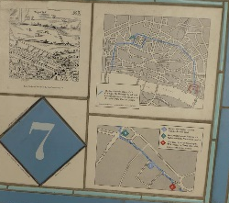

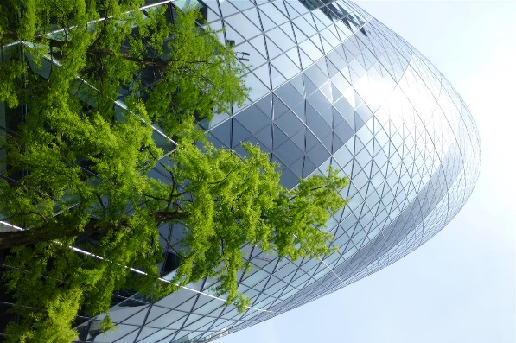

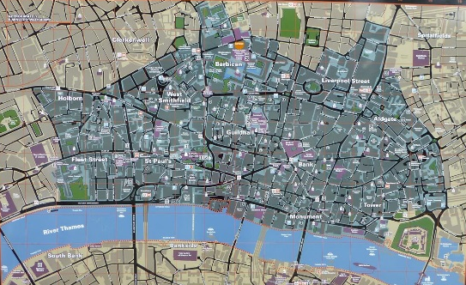

Notes from many sources including the London Museum and Wikipedia with grateful thanks.

